**Week - 2**

**PL/SQL programming**

**Exercise 1: Control Structures**

**Project Name** : ControlStructures

**Exercise**  : Implementing PL/SQL Using Control Structures

**Name**  : Alladi Manasa

**Superset Id** : 6373907

* **Introduction :**

This document presents PL/SQL solutions using control structures for a banking database. The goal is to manipulate customer and loan records using conditional and iterative logic.

* **Implementation :**

**Step 1:** Establish New Connection

**Step 2:** Create Tables and Insert Values

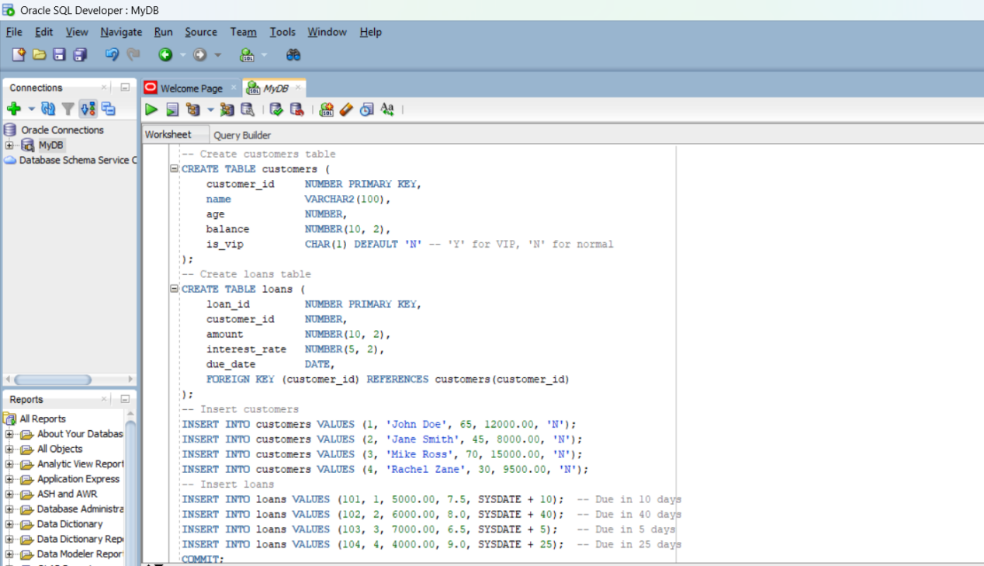

**Customers Table :**

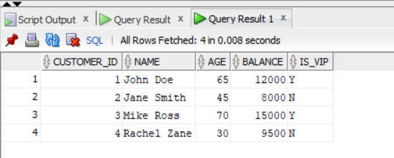

**Loans Table After Scenario 1:**

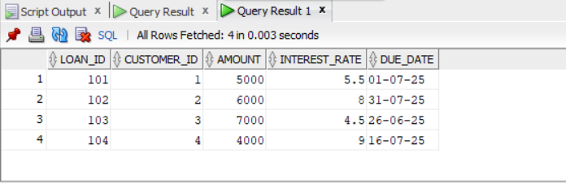

**Step 3:** Scenarios

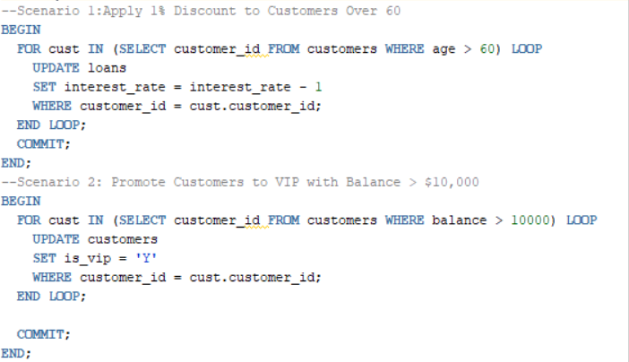

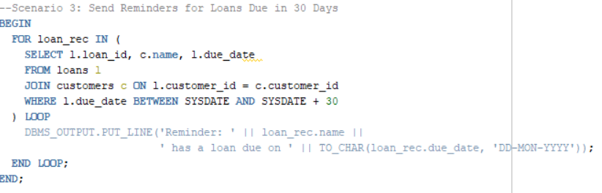

**Outputs :**

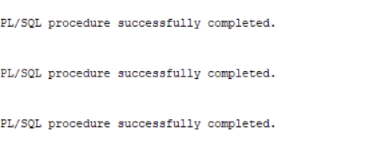

* **Outputs:**

**Scenario 1:**

After Updating Intrest_Rate:



**Scenario 2:**

Customers is IS_VIP and Balance > 10,000

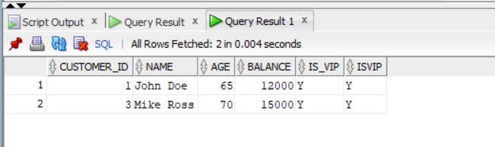

**Dbms output for Scenario 3:**

Reminders For Loans Due in 30 Days

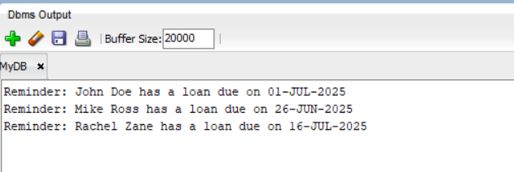

**Exercise 2 : Stored Procedures**

**Project Name** : Stored Procedures(Banking Example)

**Exercise**  : Implementing PL/SQL Using Stored Procedures

**Name**  : Alladi Manasa

**Superset Id** : 6373907

* **Introduction :**

This exercise demonstrates the use of **PL/SQL stored procedures** to automate key banking operations. It includes:

* Applying monthly interest to savings accounts
* Updating employee salaries with performance bonuses
* Transferring funds between customer accounts

These scenarios help develop skills in writing procedures, handling input parameters, and applying conditional logic in PL/SQL.

* **Implementation :**

**Step 1:** Create Tables and Insert Values

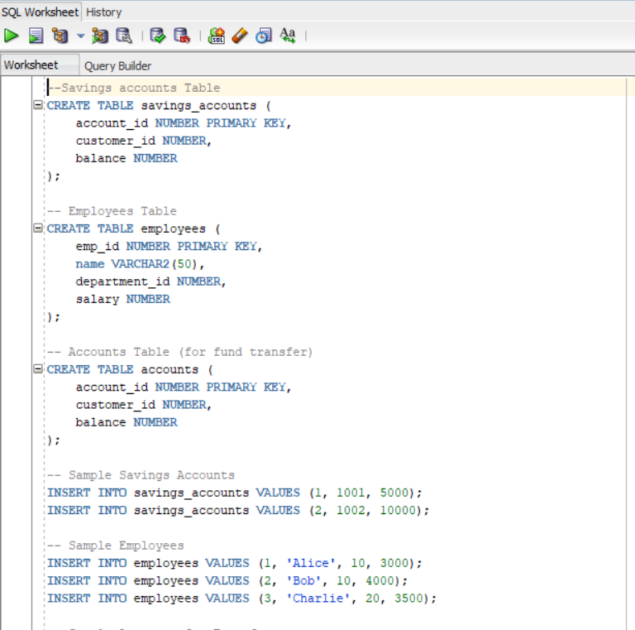

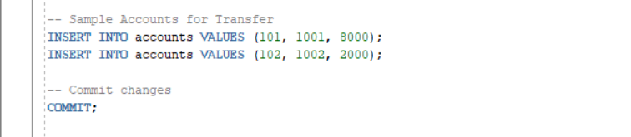

**Savings_Accounts Table :**

SELECT * FROM savings_accounts;

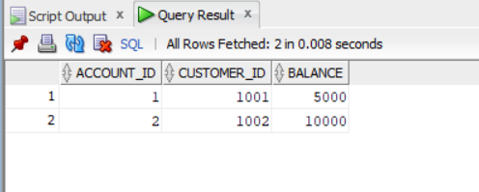

**Employees Table :**

SELECT * FROM employees;

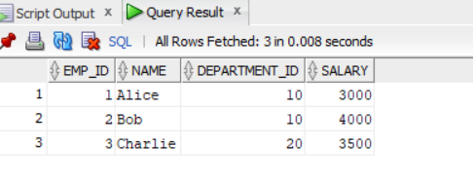

**Accounts Table :**

SELECT * FROM accounts;

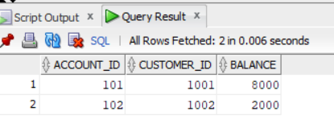

**Step 2 :** Scenarios

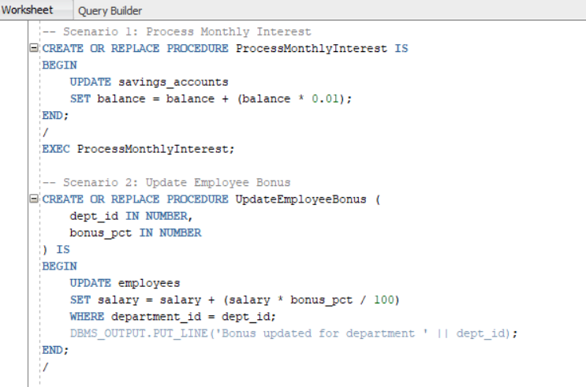

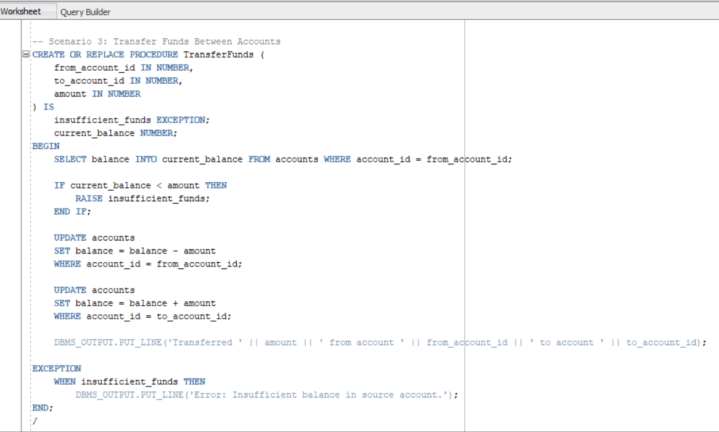

* **Procedure Execution :**

-- Execute Scenario 1

EXEC ProcessMonthlyInterest;

-- Execute Scenario 2

EXEC UpdateEmployeeBonus(10, 10); -- Dept ID 10, Bonus 10%

-- Execute Scenario 3

EXEC TransferFunds(101, 102, 1000); -- Transfer 1000 from acc 101 to acc 102

* **Outputs :**

**Scenario 1 :**

Balances in savings_accounts will increase by 1%.

SELECT * FROM savings_accounts;

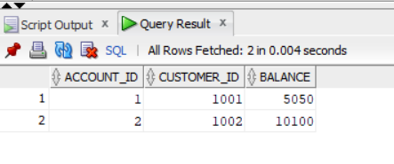

**Scenario 2 :**

Salaries updated in employees table for selected department.

SELECT * FROM employees;

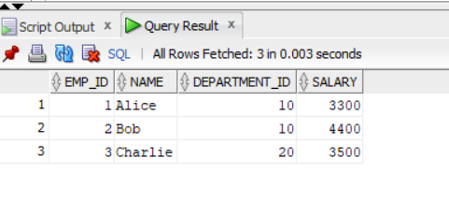

**Scenario 3 :**

Funds transferred between two accounts.

SELECT * FROM accounts;

